Business Case: Moving SQL Server Backups from the Commvault Agent to Native Backups
Oct 15, 2026 · @Parvinder Nijjar

Executive summary
Recommendation: stop using the failing Commvault SQL Server agent, take native SQL Server backups to local disk, and have Commvault back up those backup files instead.
The Commvault agent backups on the SQL Server 2005 mirrored instance are failing, so about 10 user databases have no dependable recovery point. Mirroring does not close that gap: corruption, accidental deletes and bad data changes reach the mirror immediately.
Native backups run by Ola Hallengren's maintenance scripts (weekly full, daily differential, 15-minute log) restore without Commvault and are owned end to end by the DBA team. Commvault still provides off-server copies and long-term retention, at file level. The change reuses existing tools and rolls back by re-enabling the Commvault schedules.
Decision requested: approval to cut over, and disk capacity on X:\backup sized as set out under Costs and effort.

Current state and problem
The Commvault SQL Server agent is the only backup these databases have, and its jobs are failing. The vendor will not ship a fix for this platform.
Item | Today
Platform | SQL Server 2005 SP4 on Windows Server 2008 R2; Microsoft support ended April 2016 and January 2020
High availability | Database mirroring
Databases | About 10 user databases
Backup method | Commvault SQL Server agent, failing
Vendor position | Commvault lists SQL Server 2005 as Extended Support: Tier One help only, no hotfixes or updates (agent requirements, obsolescence policy)
What the failures put at risk:
- An unknown recovery point. We can only restore to the last successful backup, not to the 15 minutes the business assumes.
- No protection from the mirror. A dropped table, a bad update or logical corruption replays to the mirror at once. Only a backup restores to the moment before it.
- Availability, not just recovery. Mirroring requires the full recovery model, so the log truncates only after a log backup. Failed log backups grow the log until its disk fills and the database stops accepting writes.
- No audit evidence. We cannot show a recent, restorable backup for these databases.
Open question: failure pattern and the date of the last good full, differential and log backup per database.
Windows Server 2008 R2 is still on Commvault's supported list for the SQL agent, so the operating system is not the blocker; SQL Server 2005 is.

Proposed solution
SQL Server writes its own backups to X:\backup, and Commvault copies those files off the server with an ordinary file-system backup.
- Backup engine: Ola Hallengren's maintenance solution (the SQL Server 2005-compatible release), run by SQL Server Agent jobs.
- Schedule: full weekly, differential daily, transaction log every 15 minutes.
- Local retention: one full, 2 days of differentials, 4 days of logs. Older restore points come back from Commvault.
- Off-server copy: a Commvault file-system backup of X:\backup, scheduled after the native jobs, on the existing retention policy.
- Alerting: Database Mail emails the DBA team on any failed backup job. A daily check also flags any database without a recent successful backup.
- Mirroring: the same jobs run on both partners. Only the principal's databases are online, so backups follow the principal after a failover; Commvault protects X:\backup on both.
With one full and 2 days of differentials kept locally, the local point-in-time window is about 2 days. The older 2 days of logs restore locally only when the weekly full is newer than them; otherwise the differential comes from Commvault. Keep differentials as long as logs if faster local restores matter.
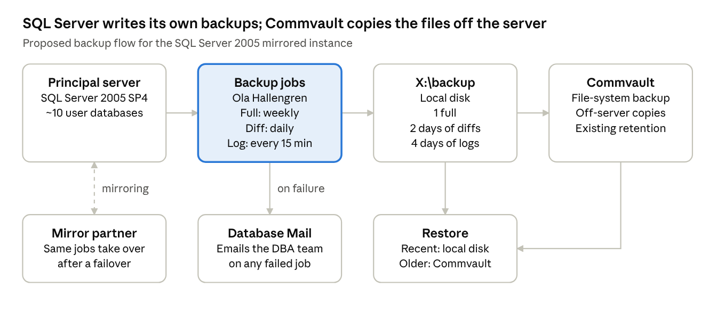
proposed backup flow · 7 parts
Recent restores come straight from local disk; Commvault supplies anything older, from either mirror partner's folder.

Options considered
Option B gives dependable backups now, with the least new dependency and a one-step rollback.
Option | What it means | For | Against | Verdict
A. Repair the Commvault SQL agent | Troubleshoot and upgrade the agent | One console and catalogue for SQL restores | SQL Server 2005 is on Commvault Extended Support, so no hotfixes; failures may recur; restores still need the backup team | Rejected
B. Native backups + Commvault file copy | This proposal | Standard SQL Server mechanism; restores with plain T-SQL; DBA-owned; keeps off-server retention | Local disk to size and watch; Commvault sees files, not databases | Recommended
C. Native backups only | Native jobs, no Commvault | Simplest | Backups sit on the same server as the data; one server loss takes both | Rejected
D. Native backups to a network share | Jobs write to a share on another server; Commvault backs up the share | Off-server from the first second; one folder for both mirror partners | Every 15-minute log backup depends on the network and a share | Worth weighing as a variant of B

Benefits
The main gain is a recovery point we can state and prove: 15 minutes on the server, and the Commvault interval off it.
- Restores without Commvault. A native .bak or .trn file restores with plain T-SQL. No agent, catalogue or backup-team ticket stands between an incident and a restore.
- Faster restores. The most recent restore points sit on local disk, so most restores need no recall from Commvault storage.
- A stable transaction log. Reliable 15-minute log backups keep the log truncating, which removes the disk-full outage risk.
- Failures seen at once. Each job emails the DBA team on failure, and every backup is recorded in msdb history.
- Standard, readable tooling. Native backup is the documented SQL Server mechanism. Ola Hallengren's scripts are free, widely used T-SQL the team can read.
- A cleaner path off SQL Server 2005. Native backups are also how these databases will move to a supported version.

Costs and effort
The costs are local disk and DBA time; the scripts are free and Commvault is already in place.
Item | Expected cost | To confirm
Disk on X:\backup | Peak space per partner, from the formula below | Free space on X: on both partners today
DBA effort | Build, cutover, two weeks of daily checks, one restore test | Days, from the team's own estimate
Ola Hallengren scripts | None; free to use | Version in use is the 2005-compatible release
Commvault licensing | Likely no change | Whether file-system protection is licensed differently from the SQL agent
Commvault storage | Likely similar to today | Deduplication ratio on the new file backups after the first month
SQL Server 2005 cannot compress backups, so local files are full size. That also suits Commvault: uncompressed, unencrypted backup files deduplicate well.
Peak local space arrives on weekly full day, because the old full is deleted only after the new one succeeds:
\text{Peak space} \approx \left(2F + 2D_{\max} + L_{4\,\text{days}}\right) \times 1.25
F is one full backup of all databases, D max the largest daily differential (the day before the full), and L the log backup volume over 4 days. The 1.25 adds 25% headroom for growth. All three can be read from msdb backup history before cutover.

Risks and mitigations
The biggest risk is two tools touching one backup chain at cutover; it is avoided by switching Commvault's SQL schedules off before the first native backup.
Risk | Effect | Mitigation
Commvault takes a SQL full or log backup after cutover | Native log chain or differential base broken; restores fail | Disable every Commvault SQL schedule first; start with a fresh native full of every database
Local cleanup deletes files before Commvault copies them | Gap in the off-server chain | Commvault file backup at least daily, logs more often; alert on any failed Commvault file job
Server or disk loss | Local copies lost with the data | Mirror partner holds a live copy; Commvault holds off-server copies; option D removes the gap
Mirroring failover | New backups land on the other partner's X:\backup; the chain spans two folders | Jobs on both partners; Commvault protects both folders; restore runbook covers both
Backup disk fills | Backups fail, then the log grows | Size with headroom; disk space alert on X:
Silent failure: Agent stopped or a job disabled | No failure email, because nothing ran | Daily check: full under 8 days, differential under 25 hours, log under 30 minutes old
Untested restores | Backups exist but do not restore | Monthly point-in-time restore to a test instance, then DBCC CHECKDB
2005-compatible scripts are no longer updated | No upstream fixes | Mature, fixed T-SQL the team can read and patch
This change makes backups dependable. It does not fix SQL Server 2005 and Windows Server 2008 being out of support; that needs its own plan.

Implementation plan
The cutover itself is one short window; the rest is preparation and proof.
- Size the storage. Read full, differential and log sizes from msdb backup history and apply the formula above to both partners.
- Deploy the jobs. Install Ola Hallengren's 2005-compatible scripts on both partners and create the full, differential and log jobs, disabled.
- Set up alerting. Add a Database Mail operator, failure notification on each job, and the daily no-recent-backup check.
- Set up the Commvault file backup. Protect X:\backup on both partners, scheduled after the native jobs finish.
- Cut over in a quiet window.
  - Disable every Commvault SQL schedule for this instance.
  - Run the native full job for every database.
  - Enable the differential and log jobs.
- Watch for two weeks. Check each day's jobs, the Commvault file backups and the free space on X:.
- Prove a restore. Restore full, differential and logs to a point in time on a test instance, run DBCC CHECKDB, and record the time taken.
- Confirm failover behaviour. At the next planned failover, check that backups follow the principal and the mirror copies are skipped cleanly.
- Close out. Remove the Commvault SQL subclient schedules for good and update the restore runbook and DR documents.
Rollback (any time before step 9): disable the native jobs, re-enable the Commvault SQL schedules and take a Commvault full. Native files already taken stay restorable.

Success measures
The change has worked when every database is provably current and a restore has been shown to work.
Measure | Proposed target
Backup currency, every database | Full under 8 days, differential under 25 hours, log under 30 minutes old
Native job success | Every scheduled job succeeds over the first 4 weeks, or its failure is emailed and fixed the same day
Off-server copy | Commvault file backup of X:\backup succeeds daily on both partners
Restore proof | Monthly point-in-time restore completes and DBCC CHECKDB is clean
Alerting | A deliberately failed test job produces an email to the DBA team
Transaction log | No log growth caused by missed log backups

Recommendation and decision required
Approve option B: native backups to X:\backup with a Commvault file-level copy, cut over in the next quiet change window.
The decision asked for:
- ☐ Approval to switch off the Commvault SQL agent schedules for this instance
- ☐ Disk on X: on both partners, sized by the formula under Costs and effort
- ☐ A change window for the cutover and a test instance for the restore proof
- ☐ Confirmation from the backup team that file-level protection of X:\backup fits the current licence

Sources
- Commvault: Microsoft SQL Server Agent: System Requirements (release 11.42)
- Commvault: Obsolescence Policy: End-of-Life, Deprecated, and Extended Support

